Jersey Number Recognition

Abstract
Automatic jersey-number recognition in sports video is an essential capability for modern sports analytics systems, providing the basis for player identification, event annotation, tactical reconstruction, and real-time broadcast enhancement. The problem is particularly challenging in due to player motion, self-occlusion, strong perspective distortions, and inconsistent camera viewpoints result in substantial variability in digit visibility. These factors prevent both conventional classification models and generic object-recognition networks from achieving stable performance. To address these difficulties, we introduce a three-stage recognition pipeline that combines geometric reasoning for pose estimation, supervised object detection for digit identification, and deep neural classification for recognition.

1. Introduction
Jersey-number recognition is a key component of automated sports analytics, as it enables reliable player identification and supports downstream tasks such as tactical analysis, event annotation, and statistical modelling. Football video makes this problem particularly challenging: players rotate quickly, move at high speed, become frequently occluded, and reveal their jersey numbers only intermittently. Even when visible, digits occupy a small and highly variable region of the torso and are easily distorted by motion, fabric deformation, lighting variation, and perspective.
To address those challenges, we adopt a structured, multi-stage pipeline that first filters frames using articulated pose estimation, then localizes digits with a YOLOv8n detector, and finally classifies them using an EfficientNet-B0 model. This decomposition enables robust jersey-number recognition in realistic football footage.
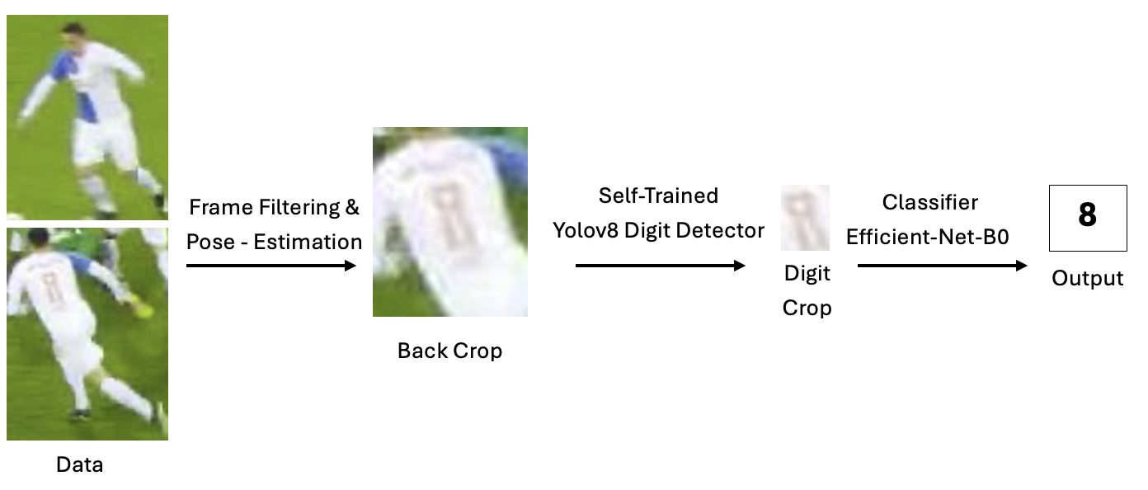

2. Related Work
Research on player identification in sports video has followed several directions, ranging from global appearance embeddings to dedicated jersey-number recognition pipelines.
Detailed modeling of digit appearance was pursued by Gen Li^{[1]} et al.’s “Jersey Number Recognition with Semi-Supervised Spatial Transformer Network,” which applies a spatial transformer module to normalize digit appearance before classification. Their method performs well when the digit region is already visible and well centered but does not fully address the challenge of detecting digits reliably in unconstrained broadcast video.
A more recent direction is the keyframe-selection strategy introduced by Balaji^{[2]} et al. (“Jersey Number Recognition using Keyframe Identification from Low-Resolution Broadcast Videos,” 2023), which identifies the most informative frames within a player tracklet to compensate for low visibility and resolution. Their method focuses on temporal scoring to isolate readable frames but does not explicitly model digit localization. The present work follows a simpler and more spatially grounded approach: instead of relying on temporal coherence, it uses pose-guided filtering to guarantee back-facing visibility and employs YOLOv8 to localize digits directly. This produces high-quality digit crops suitable for classification and extends the ideas explored in the open-source jersey-number-pipeline by ‘mkoshkina’^{[3]} through formalized filtering, dataset correction, and a complete classification stage.
3. Dataset
The dataset used in this study consists of video-derived image sequences of football players; each sequence associated with a specific jersey number. Although the dataset is nominally structured, significant noise is present. Some folders contain only images of the ball, yet are incorrectly labeled as the digit “1,” creating harmful label noise that disproportionately affects the classifier. Even when the folder corresponds to an actual player, only a small subset of frames provides a clear back-facing view required for jersey-number visibility. Many frames show the player running toward the camera, rotating, or obstructed by other players. Motion blur is prevalent and manifests strongly during sprints or rapid turns. Jersey designs vary substantially across players, creating large intra-class variance. To ensure that subsequent models train on meaningful data, substantial preprocessing is required to remove unusable frames and isolate only those that reliably depict the player’s back.

4. Methods

4.1 Pose-Guided Frame Filtering
Pose-guided filtering forms the foundation of the preprocessing pipeline. A pose-estimation model is applied to each frame, yielding a set of anatomical key points for shoulders, hips, and facial landmarks. Based on these key points, three independent criteria are evaluated:
- Orientation: inferred from the geometry of the shoulder line. The ordering and direction of the vector spanning the left and right shoulders provide a reliable cue regarding whether the player is facing toward, away from, or obliquely relative to the camera. Minimum shoulder spacing filter is also applied.
- Face-confidence: frames in which the face is detected with high confidence are also removed, since a visible face contradicts the presence of a back-facing view.
- Visual sharpness – removes frames affected by motion blur by Laplacian-filtering.
Once a frame is retained, a torso region is extracted using the coordinates of the shoulders and hips. This region constitutes the spatial domain within which digit detection is performed. The torso crop is not used directly for classification due to its variability in scale and alignment, as well as other distracting variables as player name, brands, etc. However, the back crop serves as the search area for subsequent digit-localization models.

4.2 Digit Localization with YOLOv8n
The second stage concerns the spatial localization of jersey digits. Since digits occupy only a small portion of the torso, where other distractors as player name, brands are present. Furthermore, there is perspective distortion, thus precise localization is necessary. A YOLOv8n model is trained to detect digit bounding boxes within the filtered torso regions. A curated subset of torso images is manually annotated with bounding boxes that tightly enclose each digit. These annotations are used to train YOLOv8n according to standard object-detection protocols.
During training, the model learns to regress bounding-box coordinates and classify the presence of a digit. Various augmentation techniques, including scaling and color jitter, enhance its ability to generalize. These digit crops form the basis for the final classification stage. This separation of localization and classification allows the system to focus classification capacity on the digit itself rather than irrelevant torso patterns.

4.3 Jersey-Number Recognition with EfficientNet-B0
The final stage performs jersey-number recognition based on the digit crops output by the detector. An EfficientNet-B0 architecture is adopted due to its compound-scaling strategy and strong performance in image classification tasks with limited input resolution.
Each crop is resized to a fixed resolution, normalized, and fed into the network under a supervised cross-entropy loss. Training proceeds until convergence, and the best-performing checkpoints are retained for testing. When evaluating a player sequence, several digit crops are typically available, reflecting the temporal dimension of the original video. Each crop is classified independently, and the final sequence-level prediction is obtained through majority voting across all crop-level predictions. This strategy mitigates the impact of occasional misclassifications arising from poor-quality frames or partial occlusions.

5. Experiments and Results
Initial attempts focused on end-to-end classification frameworks applied directly to torso crops. In these experiments, the back-torso region extracted from pose estimation was resized and passed to different standard convolutional architectures. Despite extensive data augmentation and training across multiple hyperparameter configurations, these models consistently failed to learn a stable mapping from torso textures to jersey numbers. The performance of these architectures remained below fifty percent accuracy even when evaluated under simplified conditions. The primary cause of this underperformance was mainly distractors like name, brands, background, shadows, as well as the extremely small spatial footprint of the digits relative to the torso crop.
Variants of the torso-classification approach were also explored, including static cropping of the back region without pose estimation, as well as manually tuned rectangular crops positioned heuristically in the upper central torso area. These simplified methods proved equally ineffective. Because the precise location of the digit varies substantially with posture, perspective distortion, camera angle, and individual jersey fit, fixed-position or loosely aligned crops seldom contained complete digit information.
A direct localization-free approach was also tested in which a backbone CNN attempted to jointly localize and classify digits using a global classification head without bounding-box supervision. However, it proved unable to isolate the digit sufficiently to support accurate recognition. The absence of supervised localization resulted in diffuse activation maps and unstable learning dynamics, again yielding accuracies far below fifty percent.
A recurrent architecture was also explored in the form of an LSTM-based CRNN, motivated by the idea that temporal aggregation across multiple YOLO digit crops might improve robustness. However, this approach consistently underperformed relative to the simpler EfficientNet-B0 classifier. The primary issue arises from the high variability of the YOLO crops themselves: individual crops differ substantially in viewpoint, digit visibility, degree of deformation, illumination, and overall quality.
These early failures motivated the transition toward a multi-stage architecture. The experiments confirmed that jersey-number recognition cannot be reliably achieved without explicit digit localization. The digits must be isolated before any semantic classification can take place, and the classifier must operate exclusively on these localized regions. During the training of the classifier, it became evident that the distribution of digit crops was highly unbalanced. This imbalance introduced a strong risk of overfitting, as the classifier tended to memorize the visual characteristics of overrepresented digits instead of learning a generalizable mapping from digit shape to class identity. To mitigate this effect, a cap of 300 images per jersey-number folder was imposed during training. This cap ensured that no single class dominated the optimization process and that the classifier was exposed to a more uniform sampling of digit appearances. Empirically, the model trained without the cap displayed unstable validation performance and a tendency to bias toward the overpopulated classes, whereas the capped dataset produced substantially more stable training dynamics and improved generalization across all jersey numbers. By constraining the maximum number of samples per class, the classifier was encouraged to learn a balanced representation of digit variations rather than relying on frequency-driven shortcuts.
The results obtained from YOLO-derived digit crops contrasted sharply with the poor performance of the earlier methods. After integrating YOLOv8n for precise localization, the classification accuracy of EfficientNet-B0 increased dramatically (65%), and the majority-vote aggregation across frames produced stable and repeatable jersey-number predictions.

6. Conclusion
This work presents a complete, robust, and fully implemented methodology for jersey-number recognition in football video. The combination of pose-guided dataset refinement, YOLO-based localization, and EfficientNet-based classification yields a system capable of handling the severe variability inherent to sports video. The method is extensible, computationally efficient, and well suited for integration into larger player-tracking or match-analysis frameworks.

Bibliography
[1] G. Li, Y. Zhang, K. Huang, and J. You, “Jersey number recognition with semi-supervised spatial transformer network,” IEEE Transactions on Circuits and Systems for Video Technology, vol. 28, no. 12, pp. 3467–3477, 2018.
[2] A. Balaji, P. Narayana, and C. V. Jawahar, “Jersey number recognition using keyframe identification from low-resolution broadcast videos,” in Proc. ACM Multimedia Asia, 2023.
[3] mkoshkina. (2022). jersey-number-pipeline [Computer software]. GitHub. https://github.com/mkoshkina/jersey-number-pipeline




Output
Classifier
Efficient-Net-B0
Back Crop
8
Frame Filtering &
Pose - Estimation
Digit Crop
Self-Trained
Yolov8 Digit Detector
Data

